Pergunta 1

Convert the following diagram to computer code in Python.

The operations should be done sequentially. Be aware of the precedence of the operations and that operands higher up in the diagram have precedence over operands lower down, where the inputs are integer numbers that occur from top to bottom:

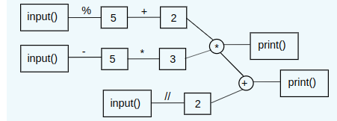

Por exemplo:
Entrada | Resultado
10  5  2 | 0  1
2  5  10 | 0  5
33  19  7 | 210  213
-3  10  -53 | 60  33

Pergunta 2

In the previous year the assessment of practical components for this course consisted of 4 tests (PE1, PE2, PE3, PE4). The last test was taken only by students who failed to obtain a minimal grade of 40% on PE3. The practical grade (PE) was computed as follows:
- if the student failed to obtain at least 40% on either PE3 or PE4 then he or she fails the course with grade "RFF"
- otherwise the grade is the average of the best 2 out of PE1, PE2 and MAX(PE3,PE4)

Write a Python program that reads the grades for the 4 tests (PE1-PE4) as integers from 0 to 100 and computes and writes the result practical grade as an integer from 0 to 100 (or "RFF"). The result should be rounded to the nearest integer.

Por exemplo:
Entrada | Resultado
80  70  50  0 | 75
80  60  35  50 | 70
100  100  35  35 | RFF
30  50  40  0 | 45

Pergunta 3

We can approximate the cosine function using a Taylor series expansion:
cos(x)=∑∞k=0(−1)k/(2∗k)!∗x(2∗k)=1−x2/2!+x4/4!−x6/6!+...
where n!=1∗2∗...∗(n−1)∗n is the factorial of n (see math.factorial).
Define a function approx_cos(x, n) that computes the cosine of x using n terms in the series above. For example: approx_cos(x, 3) should compute 1−x2/2!+x4/4!.
The result should be rounded to 5 decimal places.

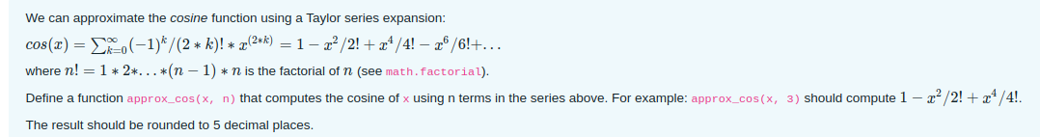

Por exemplo:
Teste | Resultado
print(approx_cos(1.0, 3)) | 0.54167
print(approx_cos(2.0, 3)) | -0.33333
print(approx_cos(1.0, 5)) | 0.5403
print(approx_cos(-1.0, 10)) | 0.5403

Pergunta 4

Friendly numbers are pairs of distinct numbers that have the following property: one of the numbers is the sum of the proper divisors of the other number and vice-versa. The proper divisors of n are the divisors of n that are smaller than n.
For example, for the pair of numbers 220 and 284, on one hand, the proper divisors of 220 are 1, 2, 4, 5, 10, 11, 20, 22, 44, 55 and 110, whose sum is 284. On the other hand, the proper divisors of 284 are 1, 2, 4, 71 and 142 and the sum of them is 220. Hence 220 and 284 are friendly numbers.
Write a Python function check_friendly(number_one, number_two) that checks if the pair of numbers number_one and number_two are friendly; it should return one of the following strings:
- 'identical numbers: ...', if the two numbers are identical (thus not friendly)
- 'sum of divisors of ... is not ...', if the sum of the divisors of one number does not equal the other number
- '... and .. are friendly', if the sum of divisors of each number equals the other

Por exemplo:
Teste | Resultado
print(check_friendly(77, 77)) | identical numbers: 77
print(check_friendly(12, 55)) | sum of divisors of 12 is not 55
print(check_friendly(18, 21)) | sum of divisors of 21 is not 18
print(check_friendly(220, 284)) | 220 and 284 are friendly

Pergunta 5

Did you ever wonder how websites validate incorrectly typed credit card numbers very quickly? It doesn't require a vast database of valid numbers — instead a simple checksum is used.
The algorithm to compute this checksum is as follows:
- Split the number into individual digits
- Multiply each digit in turn, from the rightmost to the leftmost; the first digit is multiplied by 1 (i.e. doesn't change); the second by 2, then by 1 again and then 2 again, etc.
- Add together the digits of each of these individual parcels
- Take the remainder of the division by 10; if the result is 0 then the card number is valid, otherwise it is invalid
For example: if the card number is 4028743156781887 then the results of step 2 gives the parcels:
7,2∗8,8,2∗1,8,2∗7,6,2∗5,1,2∗3,4,2∗7,8,2∗2,0,2∗4
On step 3 we compute
7+(1+6)+8+2+8+(1+4)+6+(1+0)+1+6+4+(1+4)+8+4+8=80
The remainder of division of the result (80) by 10 is zero, hence the card number is valid.
Write a Python function validate_cc(number) that implements this algorithm to check if a credit card number is valid. If the number is valid it should return "Card number ... valid", otherwise it should return "Card number ... invalid (checksum ...)" (where checksum is the remainder computed in step 4 above).
Por exemplo:
Teste | Resultado
print(validate_cc(4028743156781887)) | Card number 4028743156781887 valid
print(validate_cc(4012888888881882)) | Card number 4012888888881882 invalid (checksum 1)
print(validate_cc(4712812834781881)) | Card number 4712812834781881 valid
print(validate_cc(4712818234781881)) | Card number 4712818234781881 invalid (checksum 7)

